**ASSIGNMENT-11**

U19CS012

1.) Design and Implement *MOD-12 Counter* in Multisim using JK Flip-Flops.

*A.) Solution:*

A MOD-12 Counter would be having **12** Valid States from 0 [0000] to 11 [1011].

We will make 4-Bit Full Counter [0-15] and Try to Reduce Valid States to **12**[0-11] using Additional NAND Gate that will take *Clear All Bits* as the Value in Counter turns out to be 12 [1100] i.e. When *First Two Bits Become One*, we will Clear all Bits.

The Concept is Similar to MOD-7 Counter Implemented Earlier in Practical 11.

*B.) Implementation:*

1.) Valid State: 0 [0000]

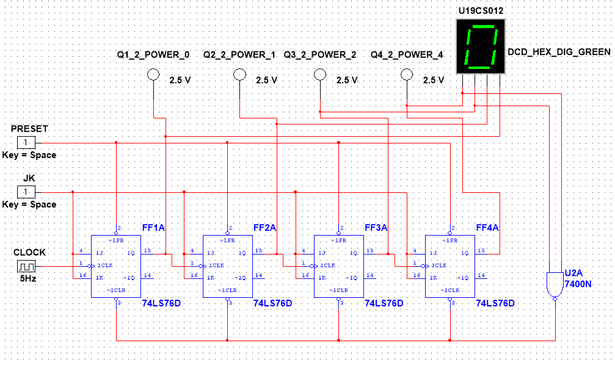

2.) Valid State: 1 [0001]

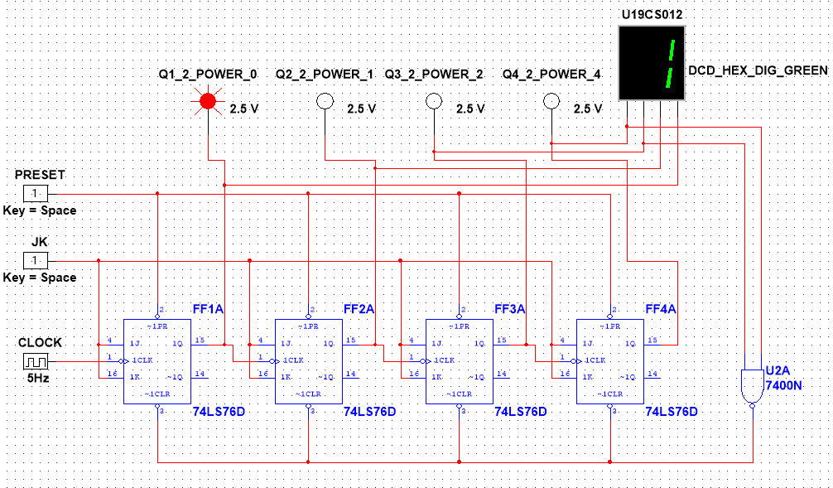

3.) Valid State: 2 [0010]

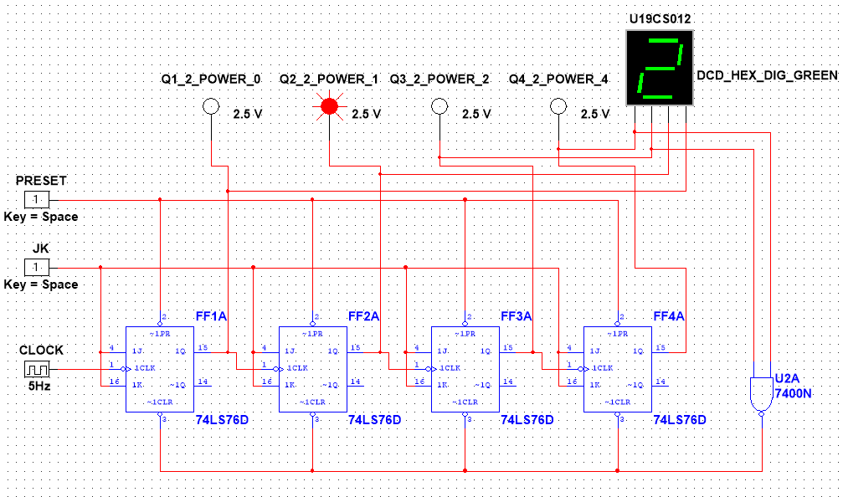

4.) Valid State: 3 [0011]

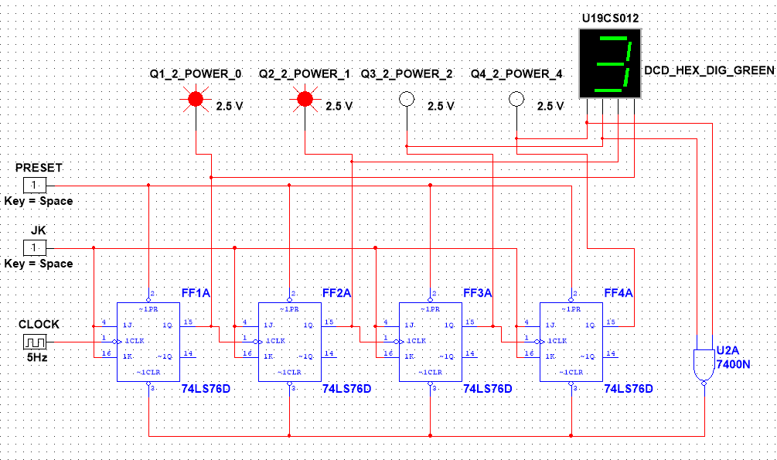

5.) Valid State: 4 [0100]

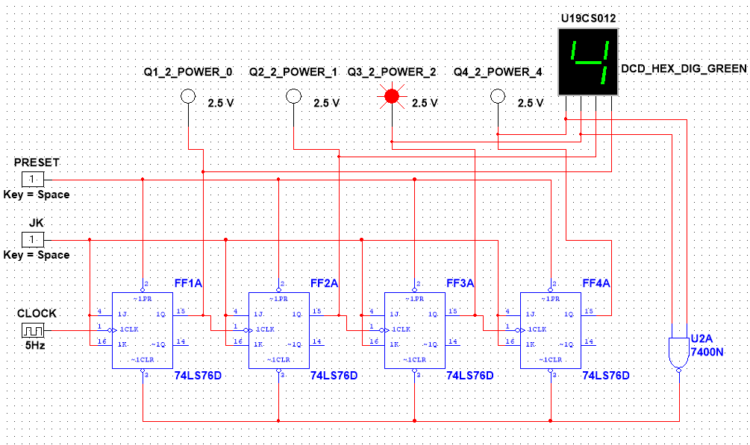

6.) Valid State: 5 [0101]

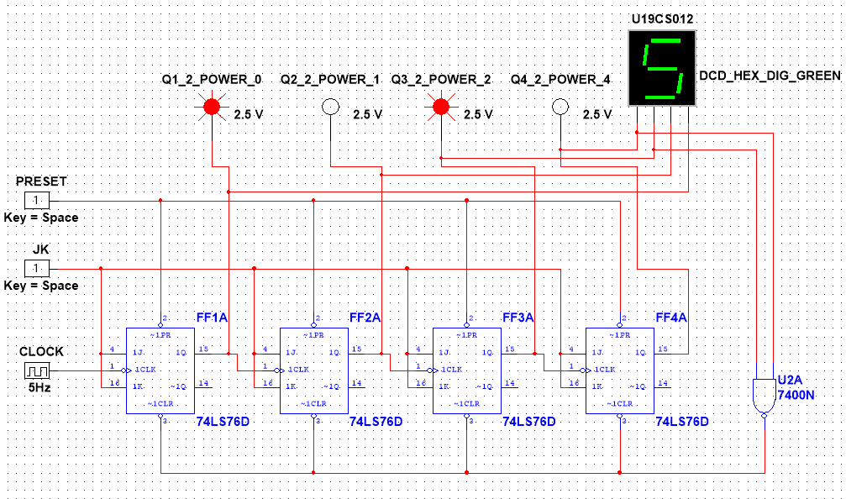

7.) Valid State: 6 [0110]

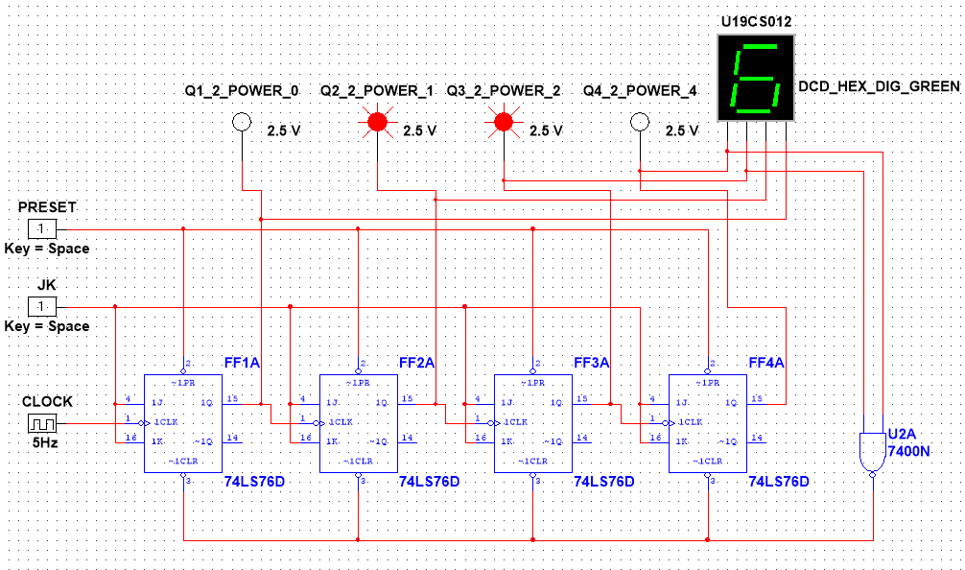

8.) Valid State: 7 [0111]

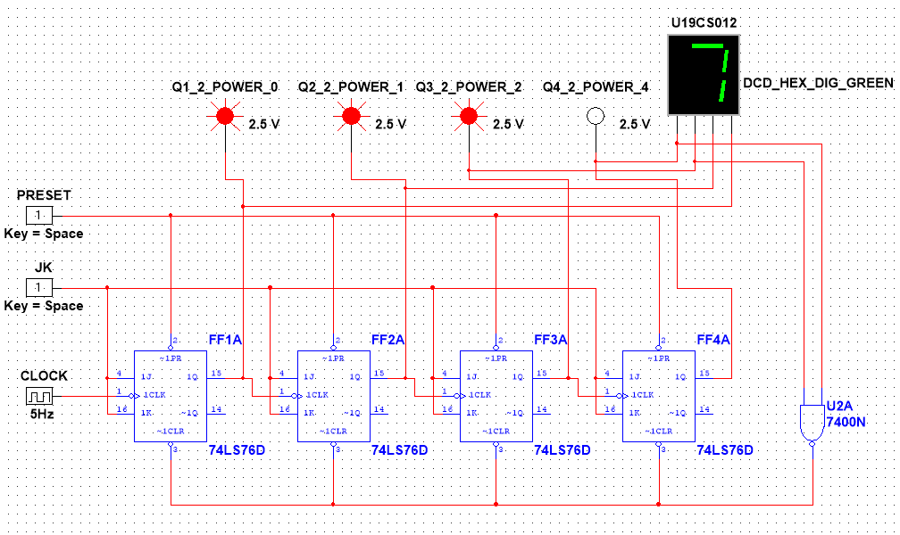

9.) Valid State: 8 [1000]

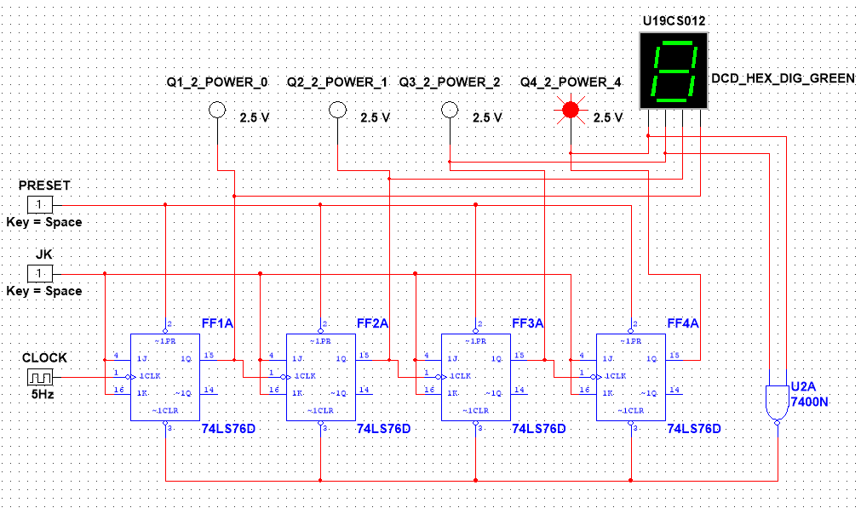

10.) Valid State: 9 [1001]

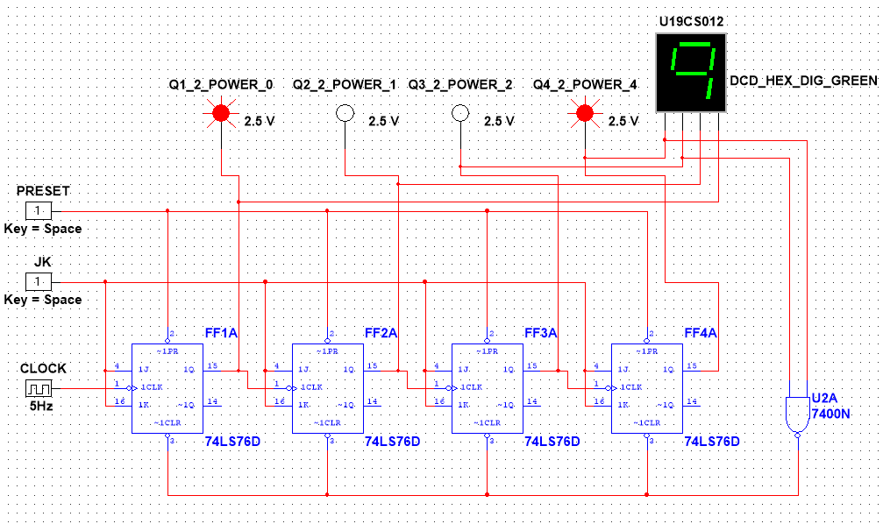

11.) Valid State: 10 [1010]

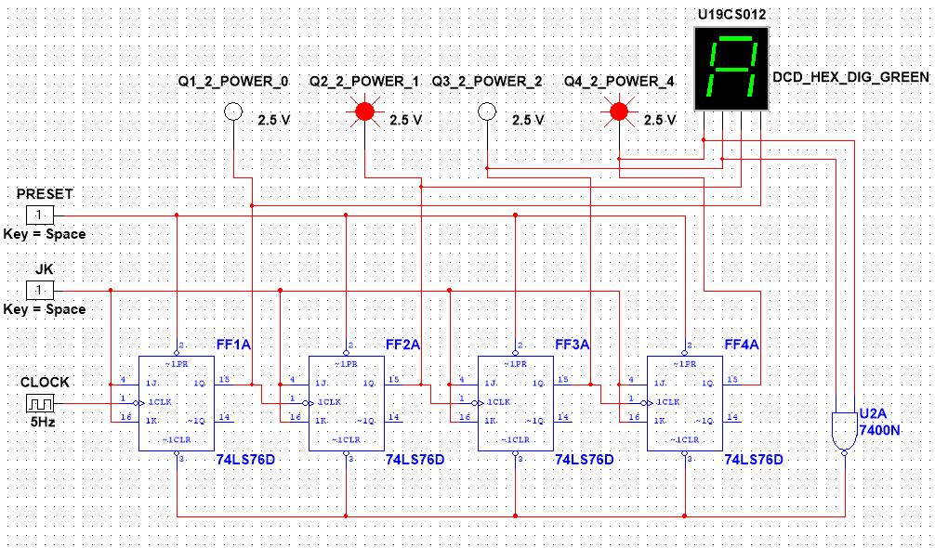

12.) Valid State: 11 [1011]

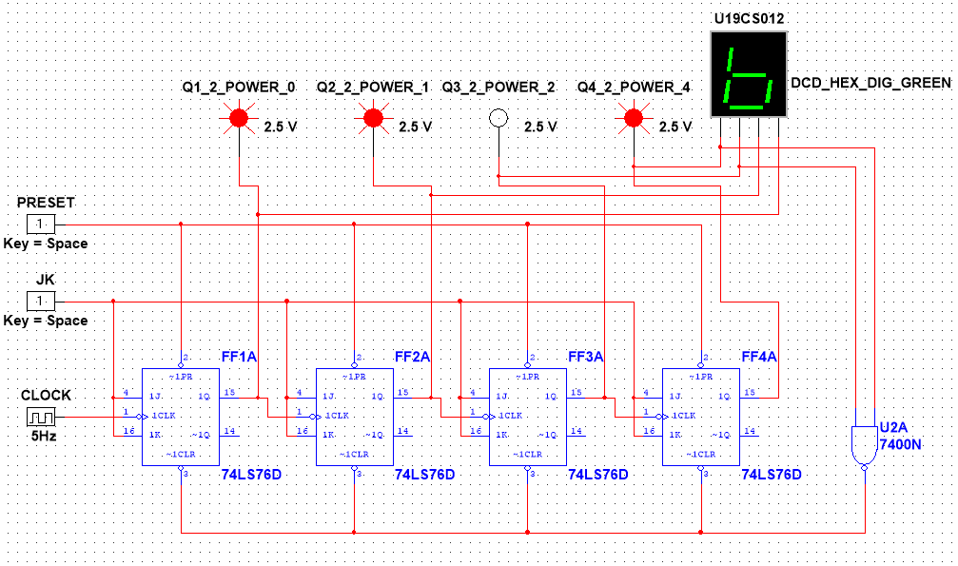

Cycle Starts Repeating Again

13.) Valid State: 12 [1100] -> 0 [0000]

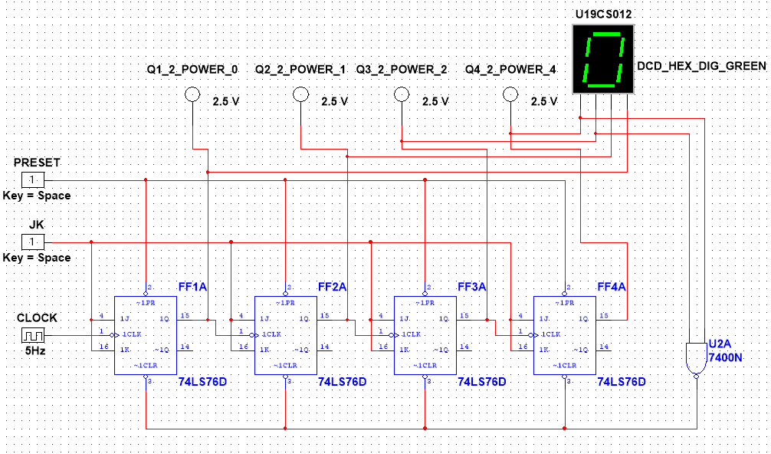

14.) Valid State: 13 [1101] -> 1 [0001]

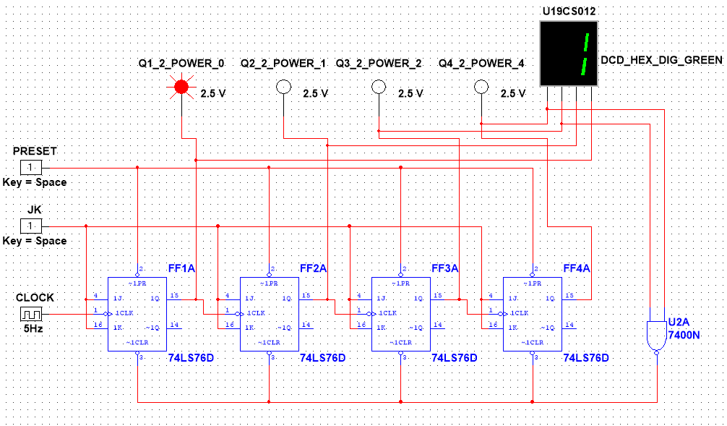

15.) Valid State: 14 [1110] -> 2 [0010]

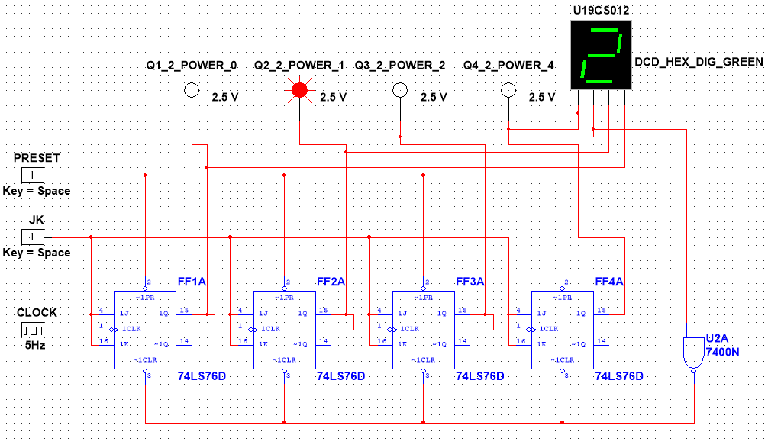

16.) Valid State: 15 [1111] -> 3 [0011]

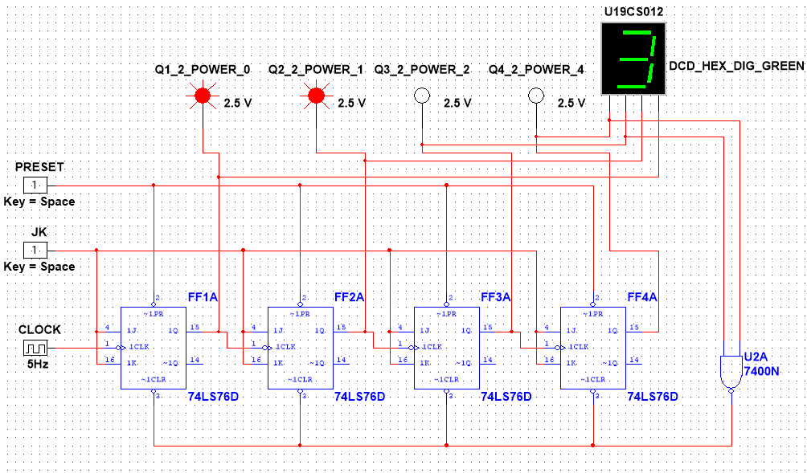

*And the Loop Continues…*

2.) Design and Implement *3-BIT Gray Code UP Synchronous Counter* in Multisim using JK Flip-Flops and Logic Gates.

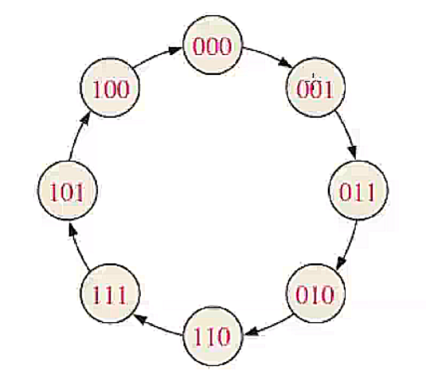

1.) Gray Code State: 000 [0]

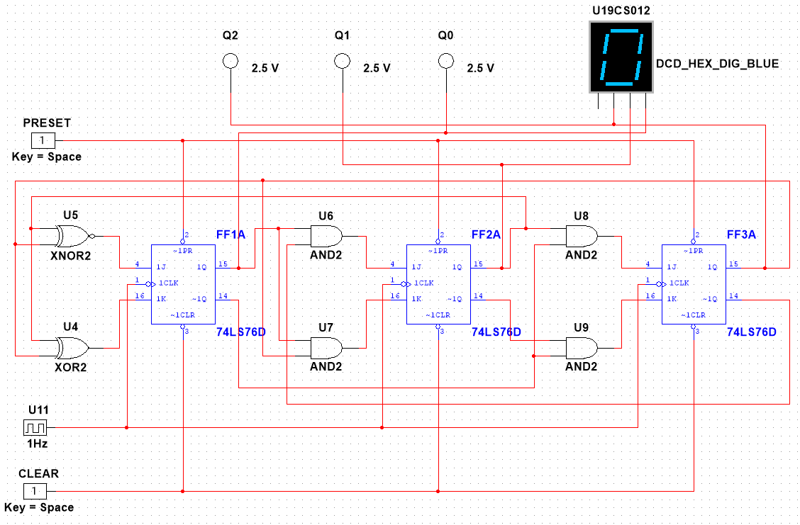

2.) Gray Code State: 001 [1]

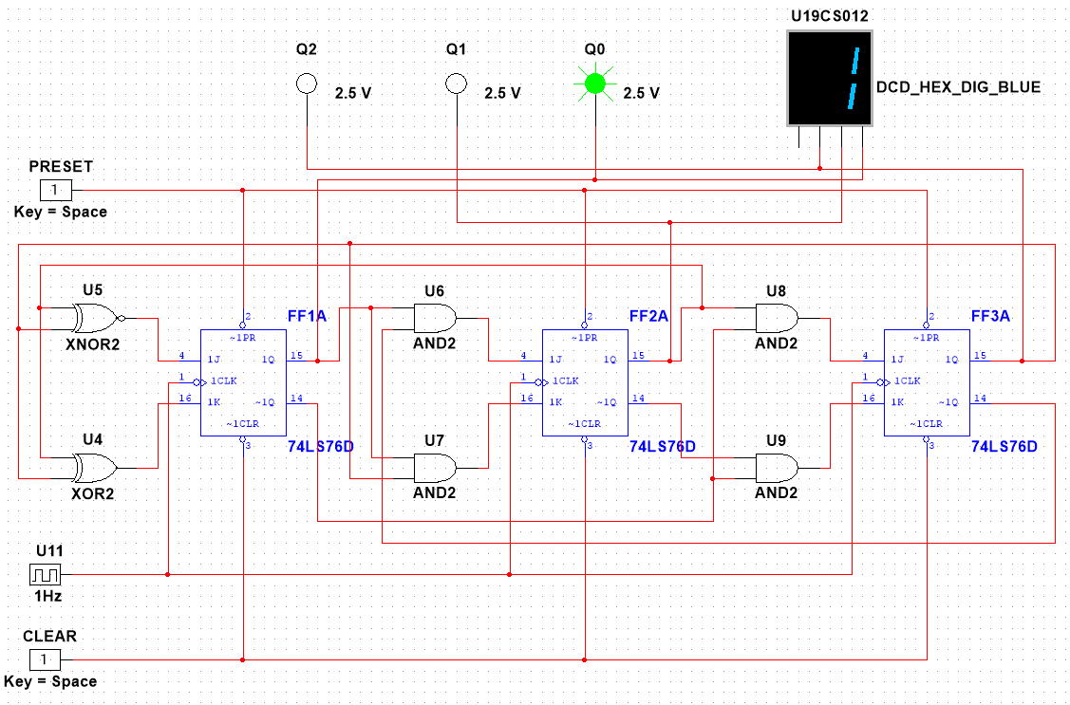

3.) Gray Code State: 011 [3]

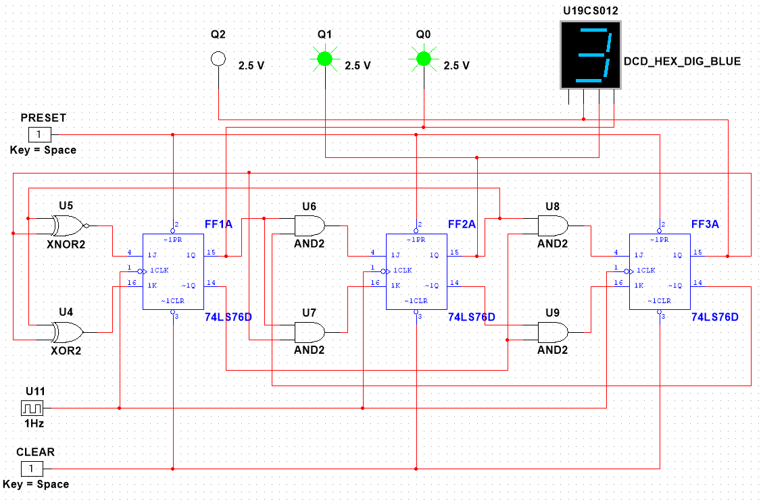

4.) Gray Code State: 010 [2]

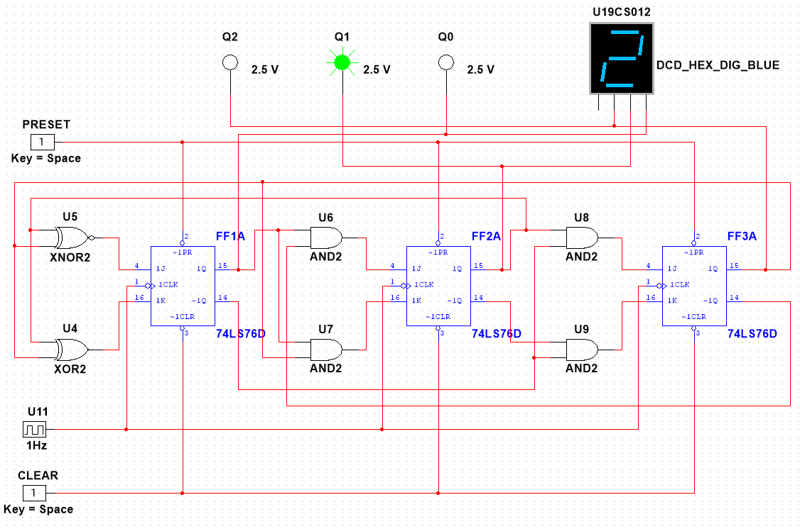

5.) Gray Code State: 110 [6]

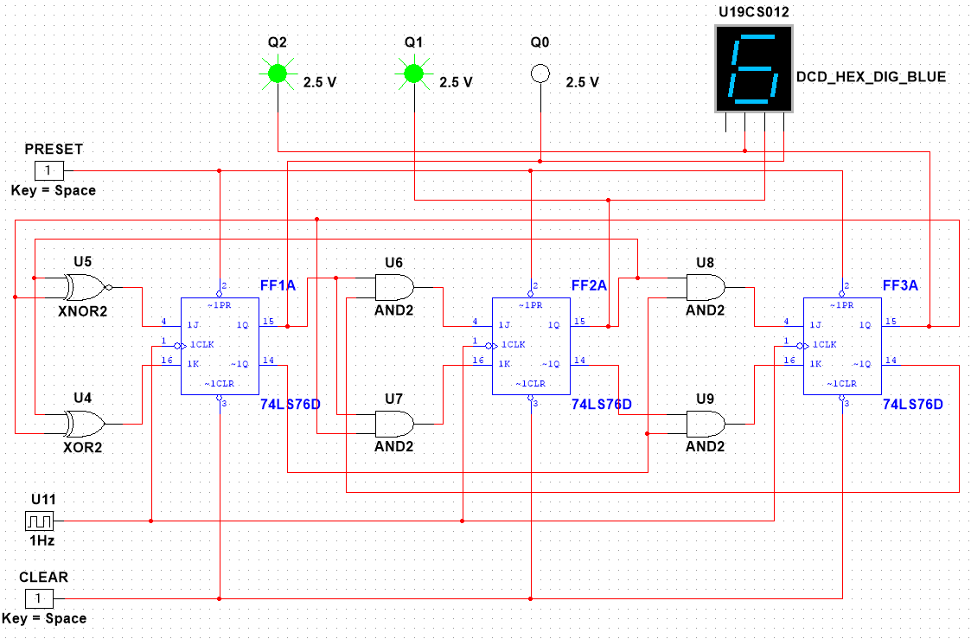

6.) Gray Code State: 111 [7]

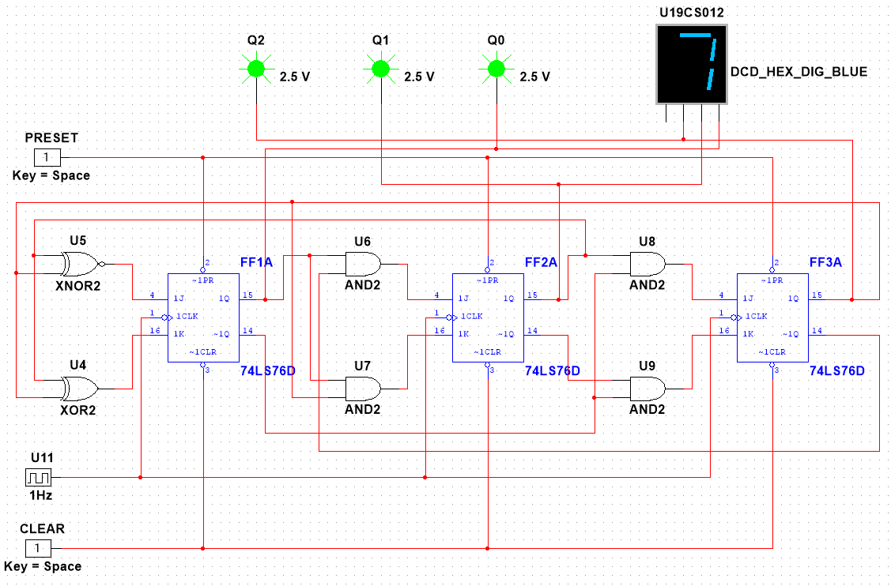

7.) Gray Code State: 101 [5]

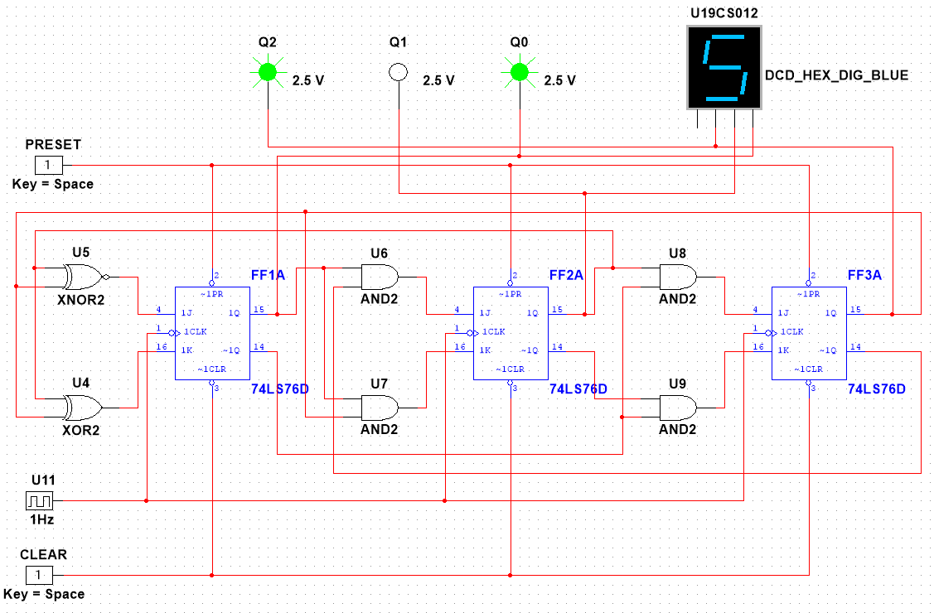

8.) Gray Code State: 100 [4]

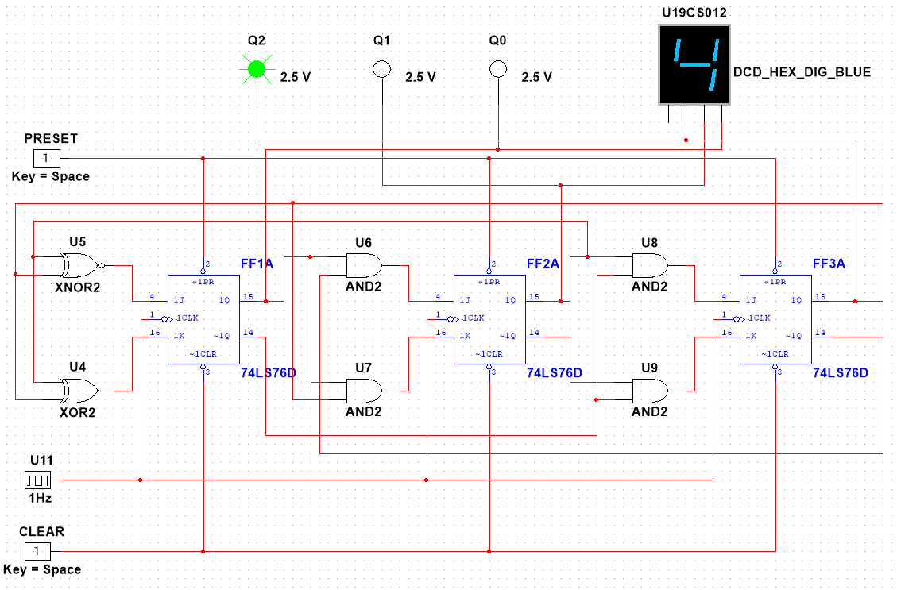

3.) Design and Implement *Bidirectional Shift Registers Using Mode Control* in Multisim using JK Flip-Flops and Logic Gates.

*A1.) Implementation:*

*Mode Control:* ***0*** *-> Shift LEFT Register*

1.) State 1: 0001

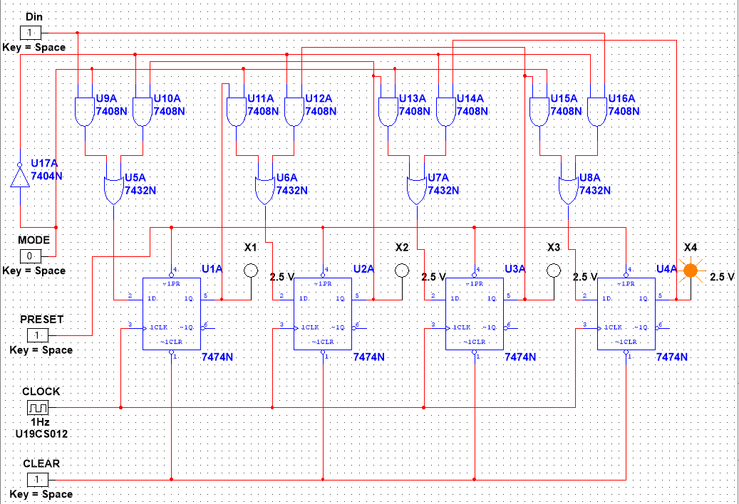

2.) State 2: 0011

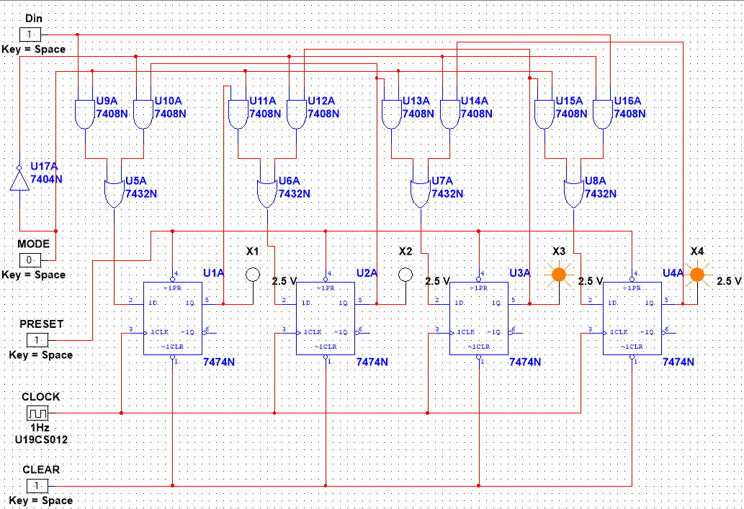

3.) State 3: 0111

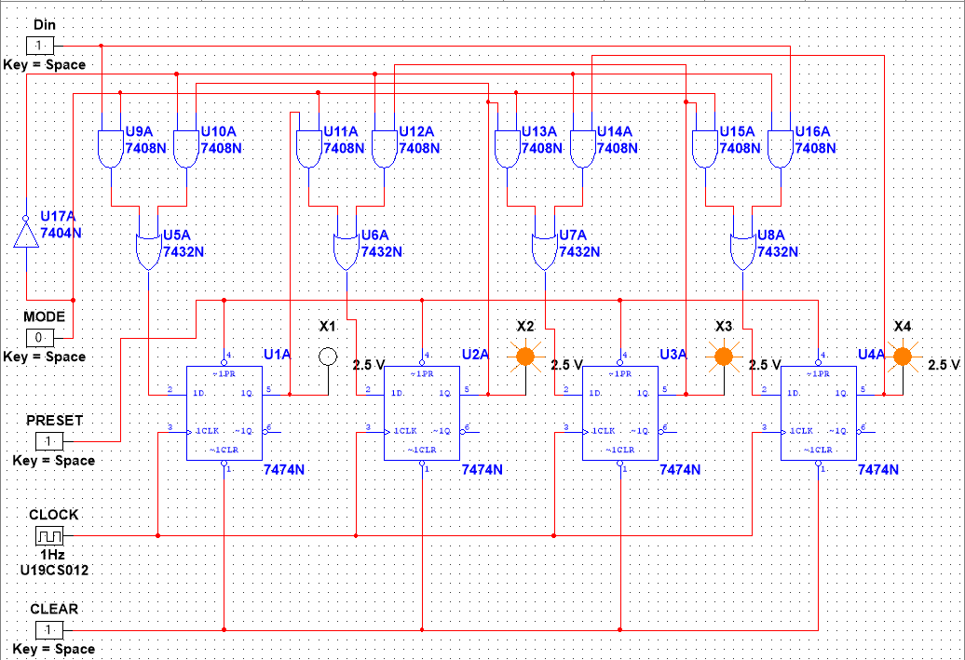

4.) State 4: 1111

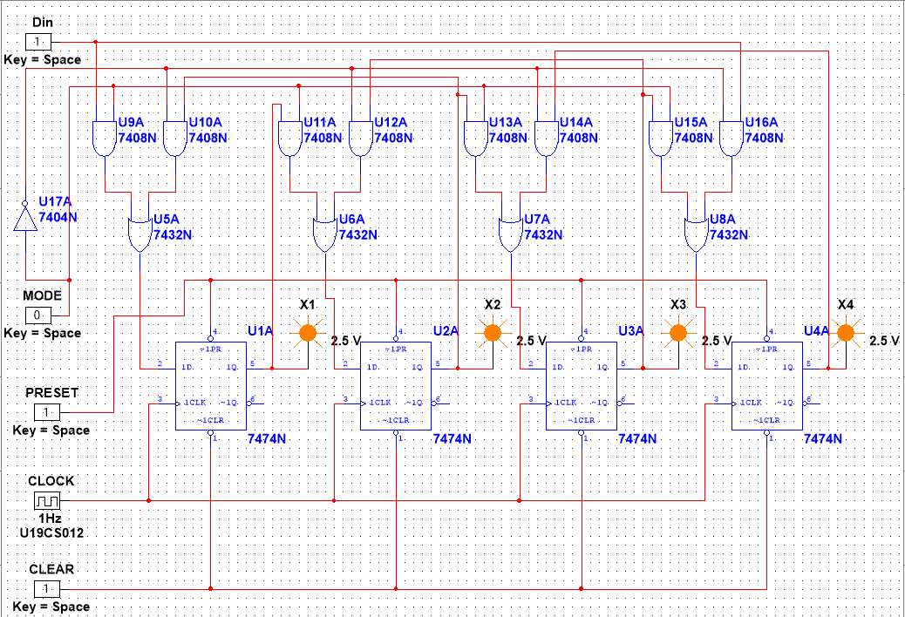

*A2.) Implementation:*

*Mode Control:* ***1*** *-> Shift Right Register*

1.) State 1: 1000

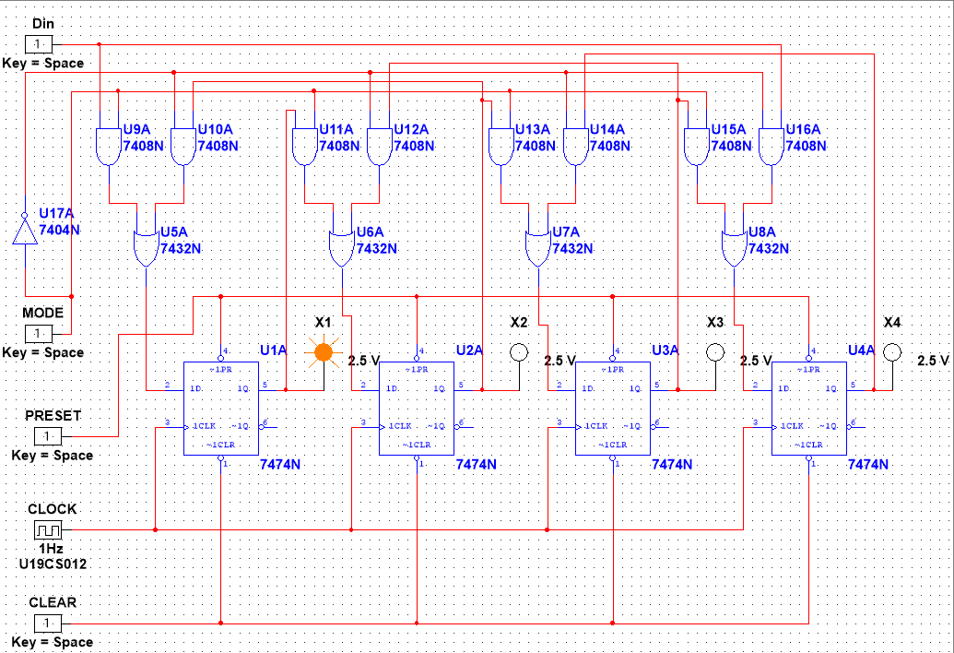

2.) State 2: 1100

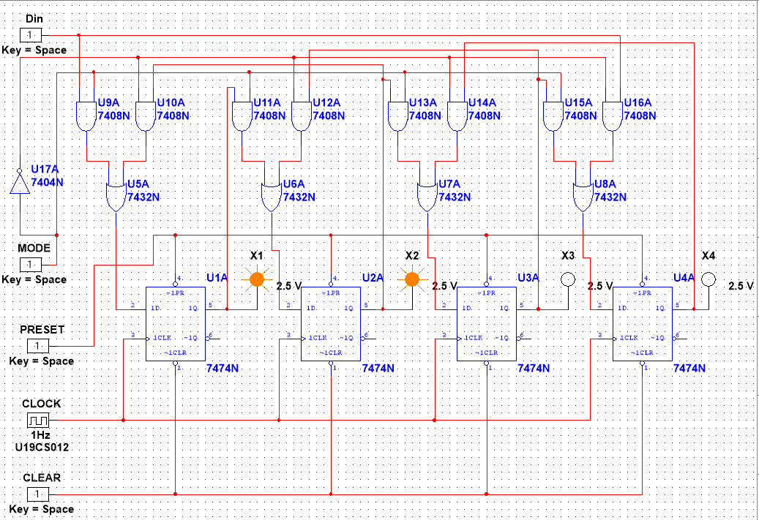

3.) State 3: 1110

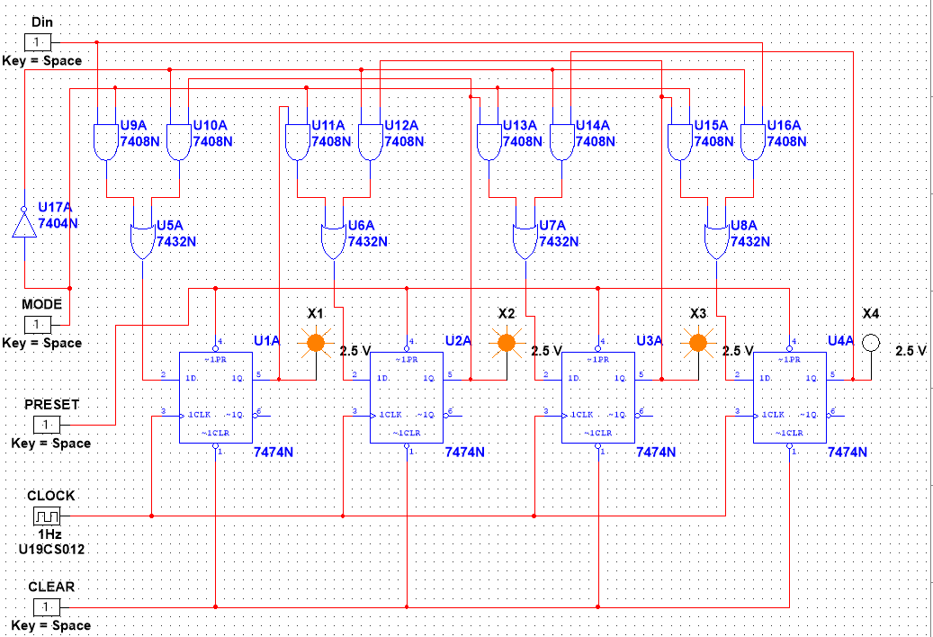

4.) State 4: 1111

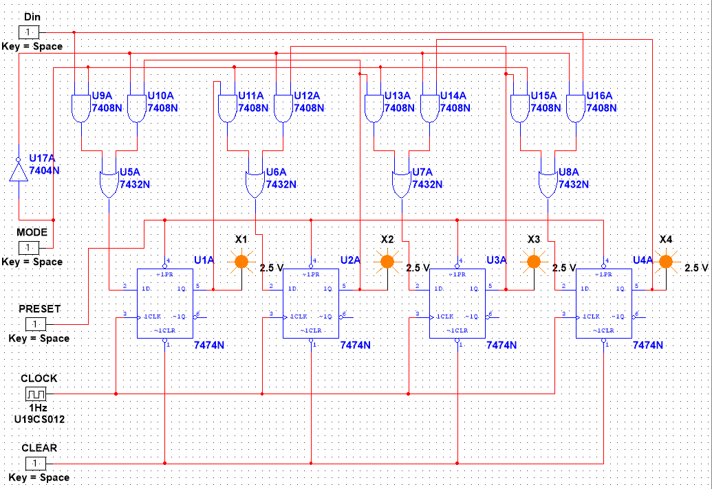

*D.) CONCLUSION:*

We have Successfully Implemented *MOD-12 Counter, Synchronous Gray Counter and Bi-directional Shift Registers [Using Mode Control]* with the Help of JK Flip-flop and Logic Gates and **verified** our **MULTISIM Outputs** and **Results** from *Theoretical Knowledge of these Circuits taught in DELD Classes.*